

**MARKING GUIDE**

**PSYCHOLOGY ATAR 2022**

**TASK 1 – Research Methods and Biological Influences**

**(Weighting: 7.5%)**

Time allowed: 60 minutes

Name: ____________________________________

|  |  |  |
| --- | --- | --- |
| **SECTION** | MARKS AVAILABLE | YOUR MARK |
| RESEARCH METHODS | **16** |  |
| BIOLOGICAL INFLUENCES | **42** |  |
| TOTAL | **58** |  |
|  |  | % |

**Question 1 Research Methods [12 marks]**

Part 1:

Miss Taylor wanted to investigate whether the type of reward offered to her Year 8 students would affect how many hours they spent studying for a Maths test. She offered a reward for students if they ranked in the top 10 of the class based on their test marks. Half the class (15 students) were offered the reward of a positive phone call home whereas the other half of the class were offered the reward of a block of chocolate. Miss Taylor gave the students a survey before they started the test, which required students to self-report how many hours of study they completed in preparation for the test.

a) Identifythe Independent Variable. (1 mark)  
Type of reward

b) State the Dependent Variable. (1 mark)

Number of hours studied

c) Create an operationalised hypothesis for this research study. (4 marks)  
Eg: Of **30 Year 8 students** (1 - sample), Those given a chocolate reward will spend **more time** (1 – predicted direction) studying for the test, as measured on a self-report **survey** (1 – method of measurement), compared to those offered a phone call reward (1 – identifying BOTH conditions).

d) Identify the **type of data** collected by the psychologist. (1 mark)  
Quantitative (accept subjective quantitative also)

d) Identify two ethical considerations which apply when conducting this study and describe how Miss Taylor could address both in her classroom. (4 marks)  
1 mark for ethical consideration and 1 mark for appropriate action.

**Eg: Informed consent/ Underage participants:** guardians receive information and sign to agree to participation.

**Withdrawal rights:** can leave study any time without ramifications/ pressure

**Confidentiality:** share no personal details

**Voluntary participation:** Do not coerce participants or offer undue compensation

Part 2:

Once the students had completed the Maths test, Miss Taylor wanted to see whether students’ level of attendance made a difference to their test scores. She created the following graph:

e) Suggest a title that could accompany this graph. (1 mark)

Test scores on a Maths test based on Attendance to class

f) Identify and describe the type of non-experimental research method used. (2 marks) Correlational study (1) – examines the relationship between two variables (1)

g) Using data from the graph, describe the results. (2 marks)

The higher percentage attendance, the higher the test score OR a positive correlation between attendance and test scores (1)

One mark for an appropriate descrption using data. E.g.:

-the scores of those who attended 100% of the time were between 80-95 whereas the scores of those who attended approx. 70% of the time were between 37-87

**Biological Influences**

**Question 2 [4 marks]**

Referring to this image, complete the table below:

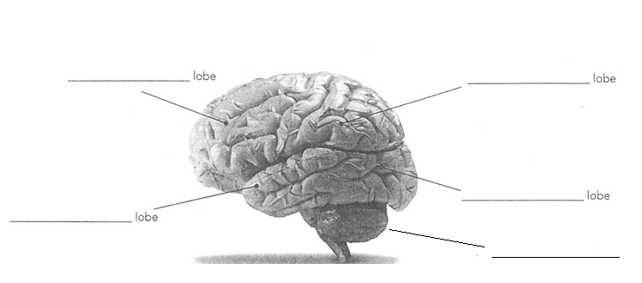

E

D

C

B

A

|  |  |  |
| --- | --- | --- |
| **Structure** | **Structure Name** | **Function of structure** |
| B | Temporal lobe | Processing auditory/sound information |
| D | Occipital lobe | Processing visual/sight information |

**Question 3 [4 marks]**

A person has a brain injury and starts to lose fine motor coordination of his muscles and walks as if he is drunk. He also finds he keeps bumping into objects. Name the two parts of the brain that have been affected by the injury and explain your choices.

Cerebellum (1) – function is to maintain posture and coordination which are lacking now (1)

Parietal lobe (1) – responsible for spatial awareness which is lacking as he bumps into things (1)

**Question 4 [8 marks]**

1. Identify the structure of a neuron shown by the labels in the illustration below. (3 marks)

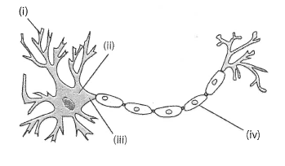

Structure of a neuron

1. dendrite
2. soma/cell body

(iv) myelin sheath

1. Describe the purpose of the structure labelled at (iv) in part (a). (1 mark)

Speed up neural transmission/protection/insulation

1. Label (iii) is the axon. Describe the function of the axon. (2 marks)

Transmit an **electrical** (1) impulse **away from the cell body**/towards next neuron. (1)

1. Draw an ARROW to show the direction of the impulse along this neuron. (1 mark)
2. What type of neuron does this diagram depict? (1 mark)

Motor neuron

**Question 5 [7 marks]**

Label the following diagram. (3 marks)

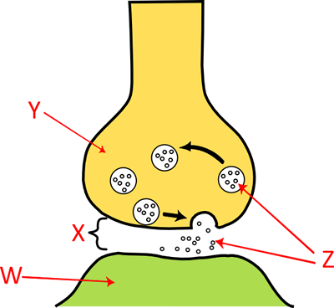

X synapse/synaptic cleft

Y axon terminal/synaptic knob

Z neurotransmitter

b. Name ONE neurotransmitter that could be released from a vesicle in the brain. (1 mark)

serotonin/dopamine/adrenaline/noradrenaline

accept any relevant response

c. Briefly explain how the neurotransmitter allows communication of an impulse to be transferred from one neuron to another. (3 marks)

Neurotransmitter released from vesicles

Diffuses across synapse

Binds to receptors on postsynaptic/next neuron

**Question 6 [6 marks]**

Drugs can have many effects on the nervous system and therefore on the psychological and physiological functions of the body.

Describe ONE psychological effect and ONE physiological effect on the body of the following drug types, AND give ONE example of each.

One mark for each:

|  |  |  |  |
| --- | --- | --- | --- |
| Type | Psychological effect | Physiological effect | Example |
| Stimulant | More alert/boost mood/ more aggressive/ increased confidence | Increased heart rate/temp/blood pressure/breathing rate  tremors | Cocaine, amphetamine, caffeine |
| Depressant | Relaxed/confused / less alert | Decreased heart rate/temp/blood pressure/breathing rate  Nausea, dizziness | Alcohol, cannabis, heroin |

Accept relevant responses

**Question 7 [7 marks]**

Researchers use various types of technology that assist them to understand the brain.

1. Describe the use of EEG (electroencephalography) to investigate brain activity. (3 marks)

Any 3 of:

-electrodes placed on scalp/external

-records intensity/frequency/amplitude of brain activity

-indicates problems such as epilepsy or tumors

-low spatial resolution/can’t detect exactly where deeper in the brain

1. Describe two differences between MRI scans and PET scans. (4 marks)

One mark for each box on two aspects only (award only if they match up):

|  |  |  |
| --- | --- | --- |
| Aspect of comparison | MRI | PET |
| Type of image | Static/still | Dynamic/moving |
| Method of action | Magnetic field and radio pulses | Glucose consumption measured/radioactive tracer |
| Limitations | Can’t image someone with metal implant | Invasive – radioactive tracer exposure |

Accept relevant responses

**Question 8 [6 marks]**

Split brain studies were conducted by Roger Sperry, in which the band of fibres between both hemispheres is severed to try to reduce symptoms in in patients with severe epilepsy. These studies have been used to explain how the left and right hemispheres function.

1. List FOUR (4) functions of the left hemisphere of the brain. (4 marks)

Any four of the following:

* Process sensation from RHS of body
* Control voluntary movement of RHS of body
* Language based tasks (note – speaking, reading, writing not given individual marks)
* Logical reasoning
* Analytical thinking
* Sequential processing

Accept other relevant responses

1. Name the collection of white myelinated nerve fibres that joins the two hemispheres of the cerebrum, and state the function of this structure. (2 marks)

Corpus callosum (1) Allows communication/ability to send messages from one hemisphere to another (1)